DPhil Meeting

Tianshu Liu

2023-05-11

Table of Contents

## Progress so far

* 7 PRSs computed (5 used PGS ID and 2 used custom score files)
* PRSs are standardised (mean=0 and sd =1)
* Age >75 at baseline, death graded above C removed
* Outcome defined as: baseline CAD+ CAD mortality (any mention on the death certificate EPA001)
* Table 1 baseline characteristics
* Correlation heatmap
* Primary analysis
* Simple analysis (no adjustment)
* Partial analysis (adjusted for age at at baseline, sex and 7 genetic PCs)
* Full adjustment (additionally adjust for smoking status, waist hip ratio, systolic blood pressure, diastolic blood pressure, education level, diabetes at baseline

## Distribution by case/control

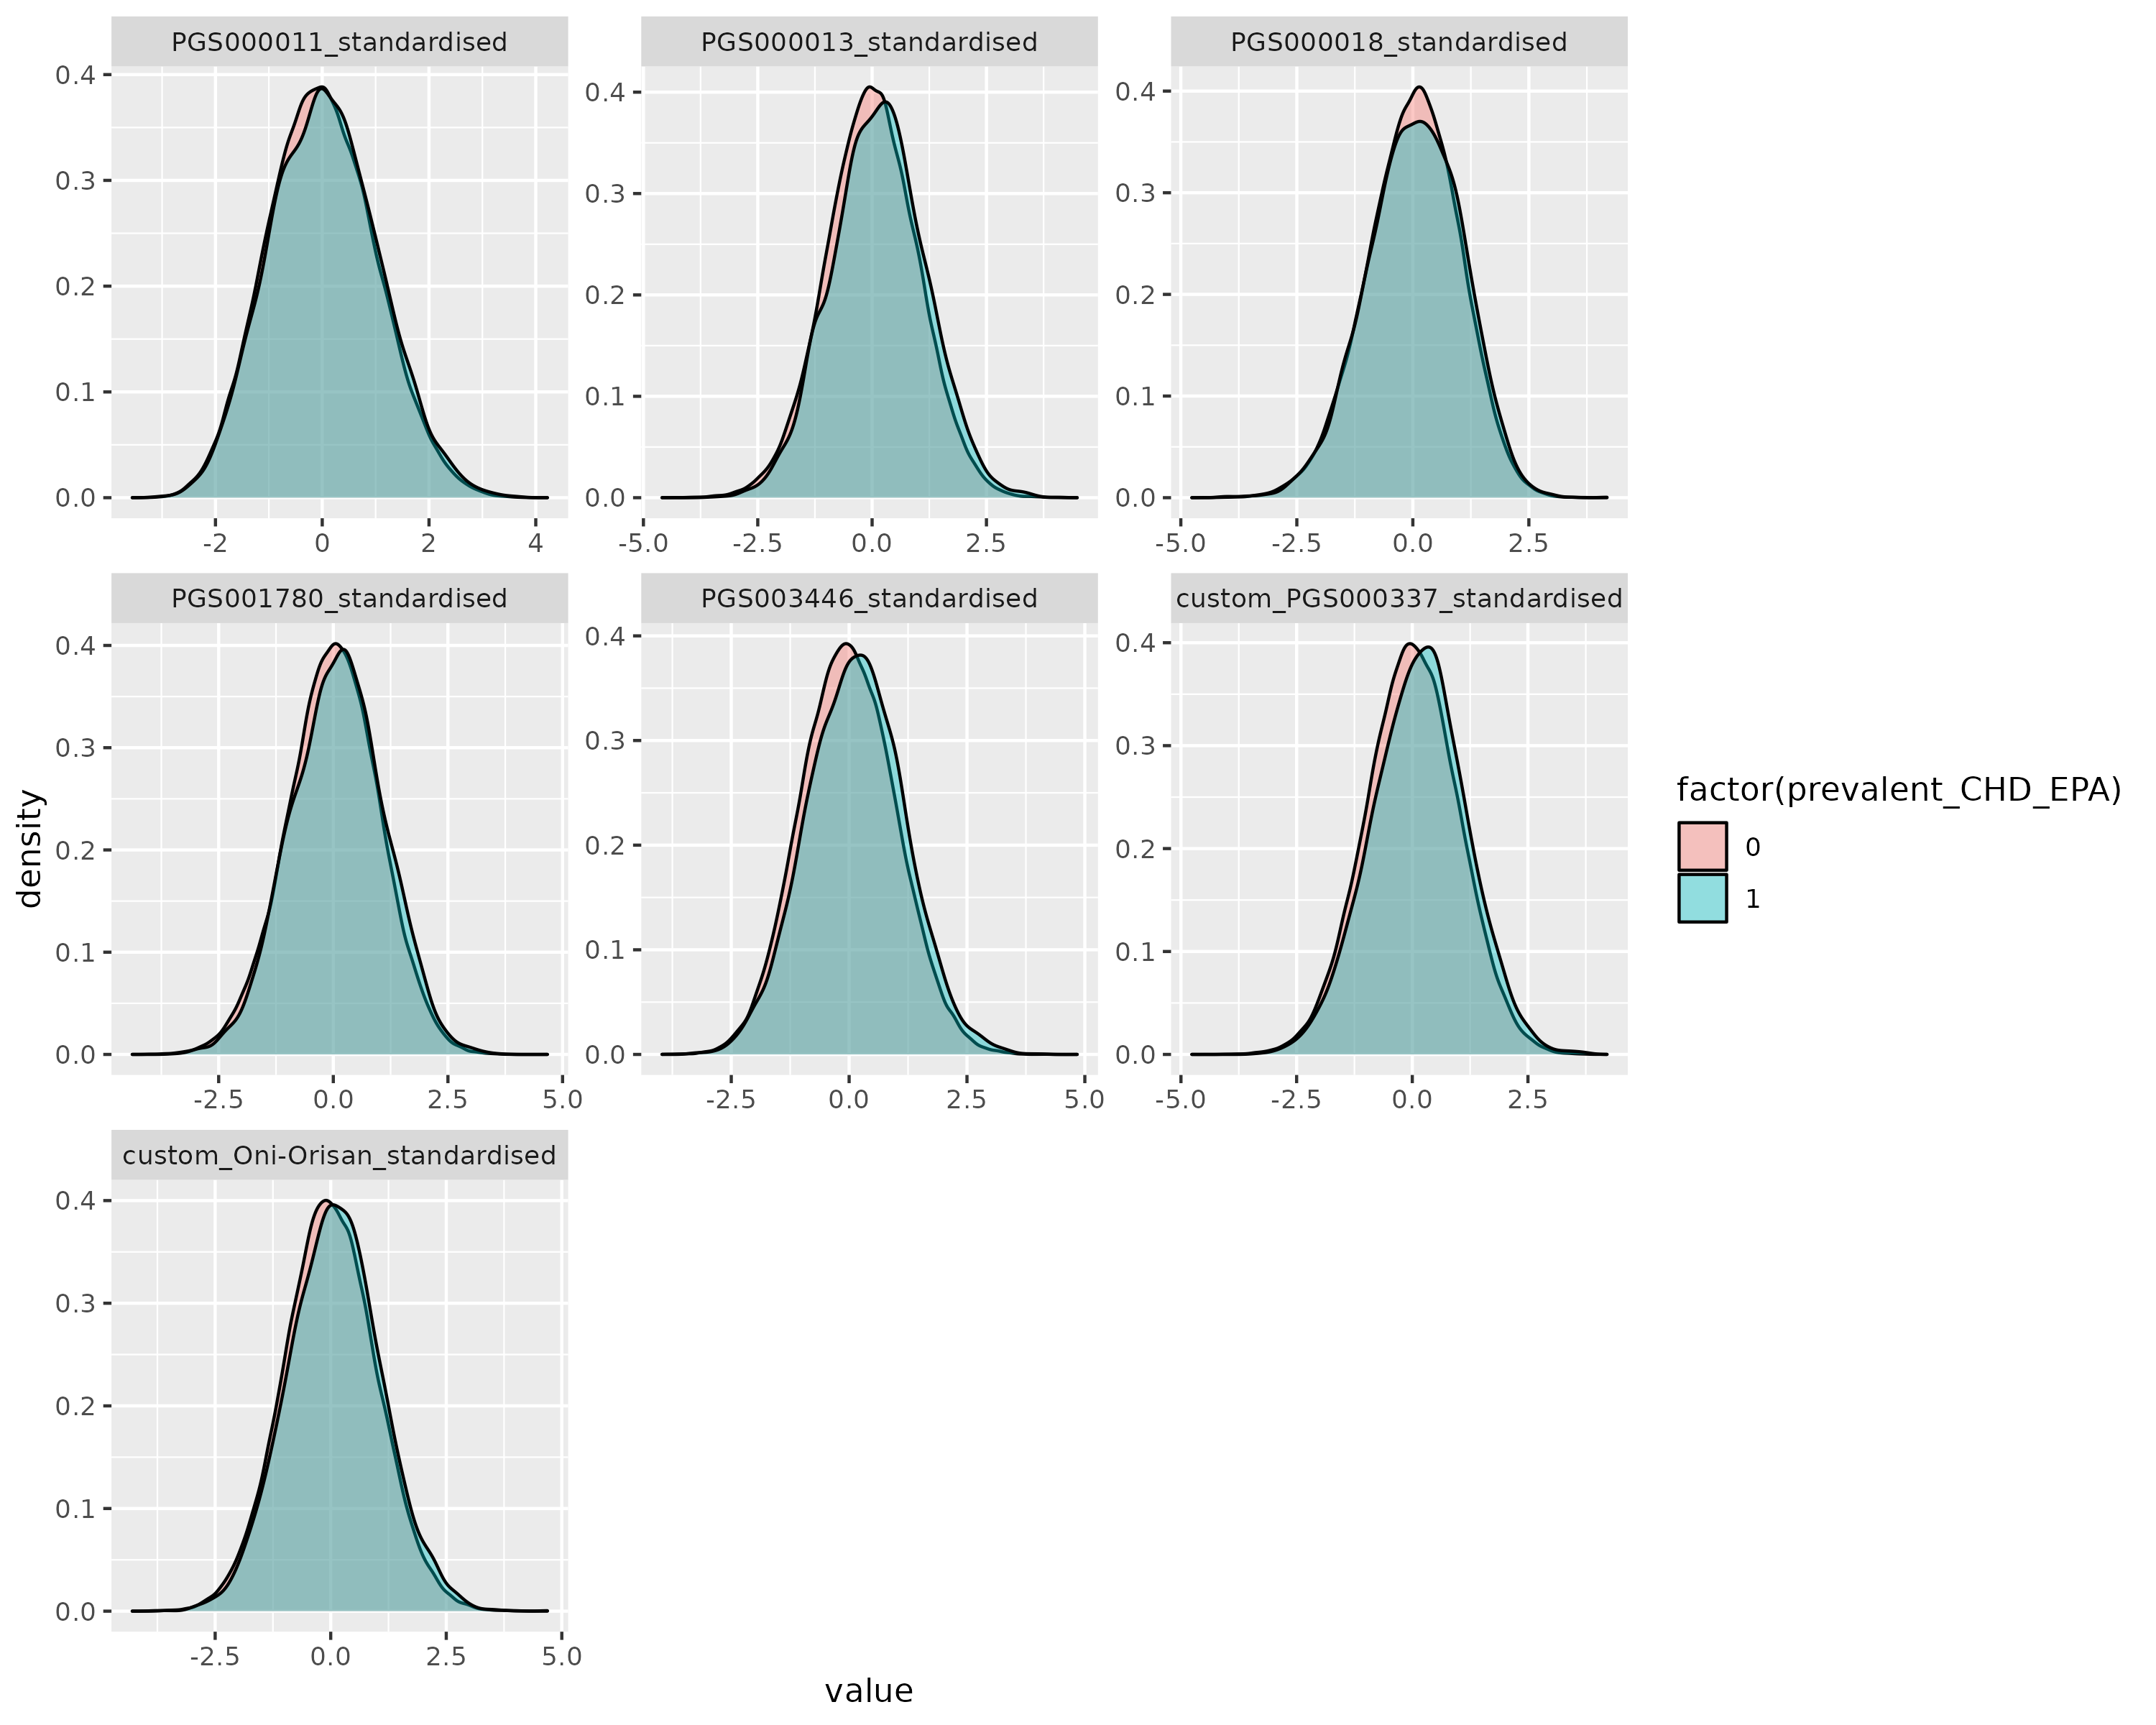

distribution by case

## Distribution by sex

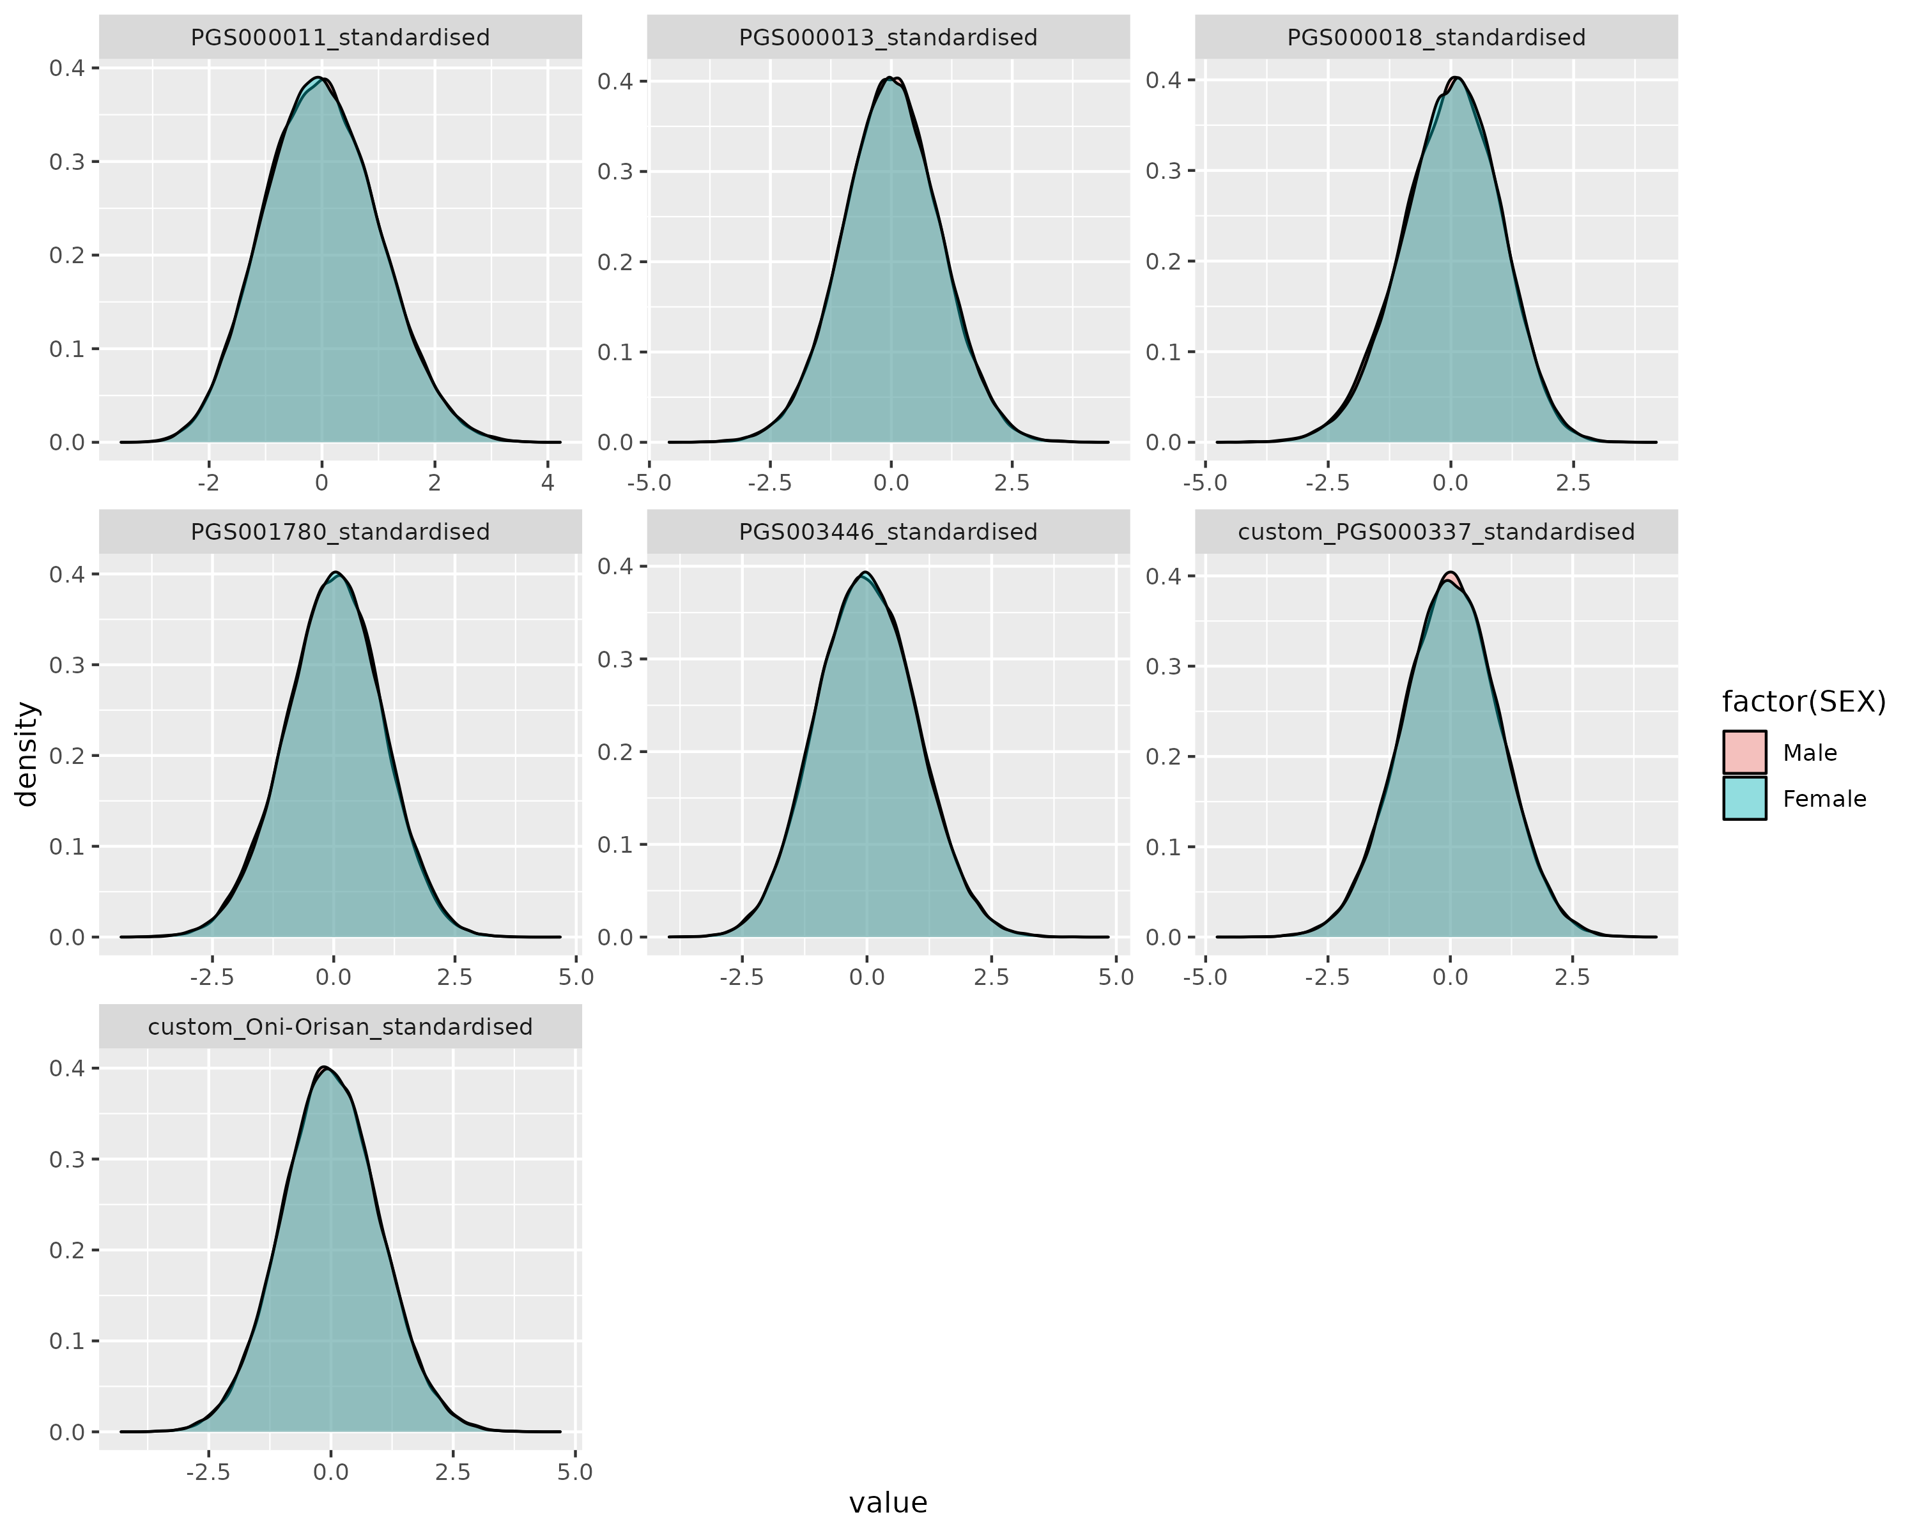

distribution by sex

## Age distribution by case/control

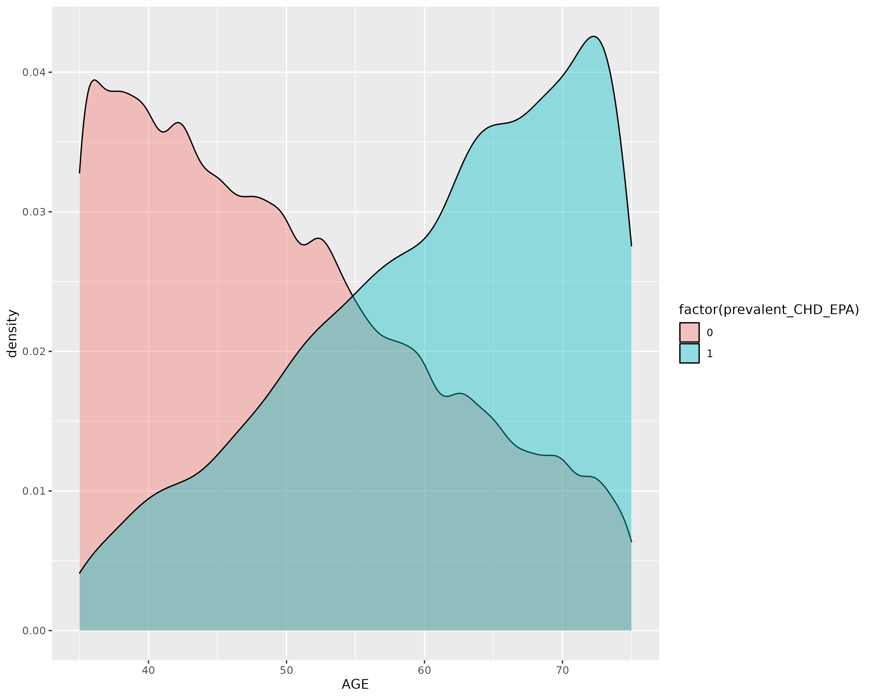

ageby case

## Age now by case/control

Age now for participants is measured at 2022/05/01 (the mortality data retrieved data?)

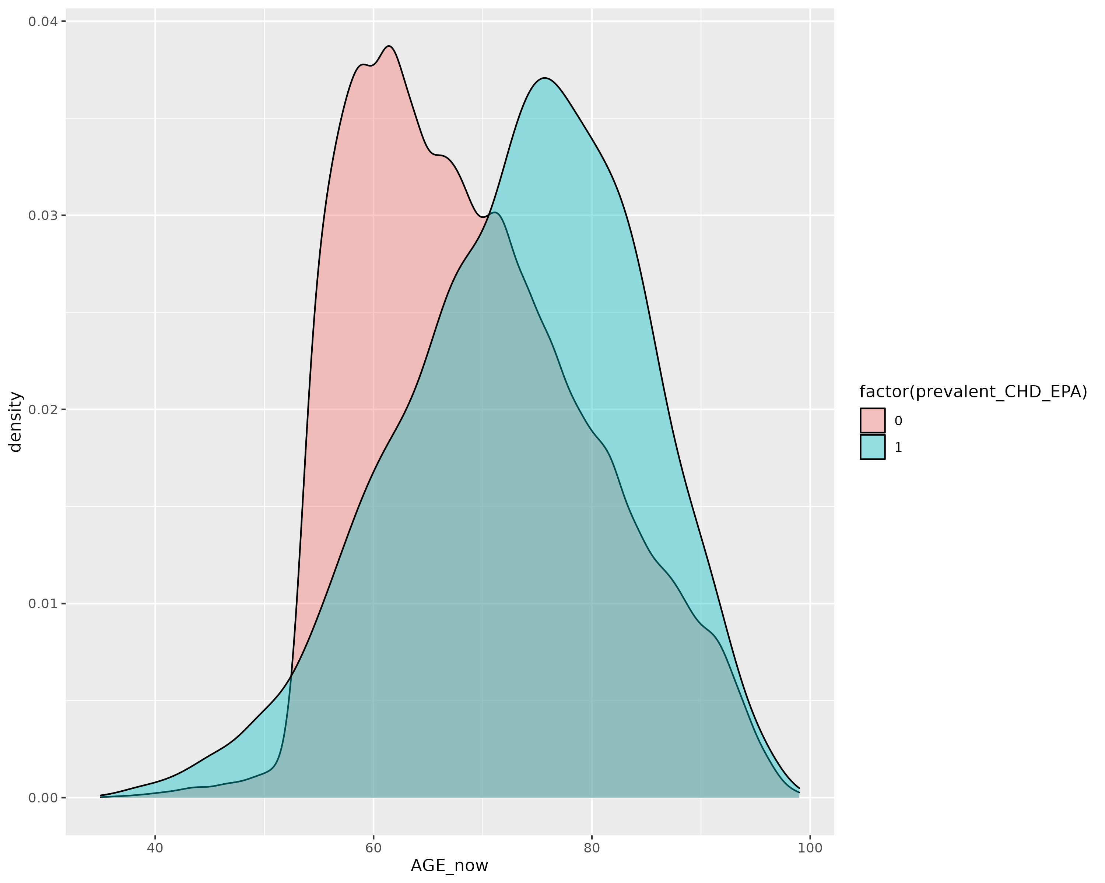

age by case

## Correlation heatmap

* PGS000011 Tada et al
* PGS000013 Khera et al
* PGS000018 Inouye et al (metascore)
* PGS001780 Tamlander et al (PGS-CS)
* PGS003446 Tcheandjieu et al (MVP)
* PGS000337 Koyama et al (Japanese trans ethnic)
* Oni-Orisan (Hispanic population)

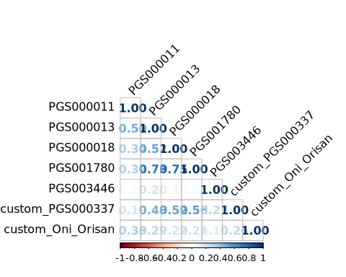

## Baseline characteristics

| **name** | **Male(N=42025)** | **Female(N=87735)** | **Overall (N=129760)** |
| --- | --- | --- | --- |
| **Age,years§** | 51.2 (11.3) | 50.1 (11.0) | 50.5 (11.1) |
| **Income(pesos/week)** | 3437.5 (5320.4) | 904.3 (2254.4) | 1724.7 (3742.9) |
| **Smoking status** |  |  |  |
| Never | 8421 (20.0%) | 54268 (61.9%) | 62689 (48.3%) |
| Ex-smoker | 14790 (35.2%) | 15371 (17.5%) | 30161 (23.2%) |
| Current (<5/day) | 10770 (25.6%) | 12743 (14.5%) | 23513 (18.1%) |
| Current (5-14/day) | 5354 (12.7%) | 4222 ( 4.8%) | 9576 (7.4%) |
| Current (>14/day) | 2681 (6.4%) | 1097 (1.3%) | 3778 (2.9%) |
| Missing | 9 (0.0%) | 34 (0.0%) | 43 (0.0%) |
| **Education level** |  |  |  |
| Uni/College | 10269 (24.4%) | 10318 (11.8%) | 20587 (15.9%) |
| High school | 11345 (27.0%) | 21835 (24.9%) | 33180 (25.6%) |
| Elementary | 17234 (41.0%) | 44007 (50.2%) | 61241 (47.2%) |
| Other | 3165 ( 7.5%) | 11526 (13.1%) | 14691 (11.3%) |
| Missing | 12 (0.0%) | 49 (0.1%) | 61 (0.0%) |
| **Leisure-time physical activity** |  |  |  |
| NONE | 29412 (70.0%) | 71361 (81.4%) | 100773 (77.7%) |
| < ONCE A WEEK | 1280 (3.0%) | 743 (0.8%) | 2023 (1.6%) |
| 1-2 TIMES A WEEK | 4363 (10.4%) | 3782 ( 4.3%) | 8145 (6.3%) |
| AT LEAST 3 TIMES A WEEK | 6961 (16.6%) | 11827 (13.5%) | 18788 (14.5%) |
| Missing | 9 (0.0%) | 22 (0.0%) | 31 (0.0%) |
| **District (Coyoacan)** | 17531 (41.7%) | 32336 (36.9%) | 49867 (38.4%) |
| **Anthopometry, NMR, blood pressure and HbA1c(%)$** |  |  |  |
| Systolic Blood Pressure(mmHg) | 128.3 (15.6) | 126.3 (16.7) | 126.9 (16.4) |
| Diastolic Blood pressure(mmHg) | 84.4 ( 9.9) | 82.4 (10.2) | 83.1 (10.2) |
| BMI(kg/m2) | 28.1 (4.4) | 29.7 (5.3) | 29.2 (5.1) |
| Waist to Hip Ratio | 1.0 (0.1) | 0.9 (0.1) | 0.9 (0.1) |
| HDL-C (nm) | 0.9 (0.2) | 1.0 (0.2) | 1.0 (0.2) |
| LDL-C(nm) | 1.7 (0.5) | 1.7 (0.5) | 1.7 (0.5) |
| Baseline glycated HbA1c (%) | 6.1 (1.7) | 6.1 (1.7) | 6.1 (1.7) |
| **Baseline Diseases** |  |  |  |
| Coronary Artery Disease | 779 (1.9%) | 954 (1.1%) | 1733 (1.3%) |
| Cardiovascular Disease | 1190 (2.8%) | 1765 (2.0%) | 2955 (2.3%) |
| Cancer | 231 (0.5%) | 1271 (1.4%) | 1502 (1.2%) |
| Diabetes (HBA1C>6.5%, self-report or take medication) | 7915 (18.8%) | 15893 (18.1%) | 23808 (18.3%) |
| Other diseases* | 2136 (5.1%) | 8508 (9.7%) | 10644 (8.2%) |
| *Other diseases include emphysema, chronic kidney disease, peptic ulcer,cirrhosis, and peripheral arterial disease. | | | |
| $Among participants with complete measurements, HDL_C and LDL_C have around 23% missingness. | | | |
| §Participants age over 75 are excluded. | | | |

## Quintile table (PGS000011)

| **PGS000011** | **Q1(N=25952)** | **Q2(N=25952)** | **Q3(N=25952)** | **Q4(N=25952)** | **Q5(N=25952)** | **Q5 VS Q1$** |
| --- | --- | --- | --- | --- | --- | --- |
| Continuous (Mean(SD)) |  |  |  |  |  |  |
| **Age, years** | 50.50516 (11.10522) | 50.49857 (11.14207) | 50.46798 (11.14684) | 50.43908 (11.07099) | 50.44609 (11.03577) | 0.54331 |
| **Income (pesos/week)** | 1717.026 (3934.652) | 1737.583 (3684.475) | 1703.488 (3647.814) | 1759.328 (3933.317) | 1706.264 (3494.355) | 0.7418 |
| **HDL-C(nm)** | 1.01129 (0.21799) | 1.01244 (0.22084) | 1.00974 (0.21895) | 1.00810 (0.21975) | 1.00479 (0.21959) | 0.00301 |
| **LDL-C(nm)** | 1.72705 (0.50112) | 1.74080 (0.50431) | 1.73567 (0.49963) | 1.74045 (0.50279) | 1.72493 (0.50120) | 0.67193 |
| **Systolic Blood Pressure(mmHg)** | 126.7114 (16.31553) | 126.7677 (16.37367) | 126.9346 (16.45679) | 126.9335 (16.40201) | 127.2567 (16.48374) | 0.00015 |
| **Diastolic Blood Pressure(mmHg)** | 82.98764 (10.16373) | 82.96766 (10.10140) | 83.04429 (10.11799) | 83.12310 (10.20423) | 83.20752 (10.22363) | 0.01406 |
| **Baseline glycated HbA1c (%)** | 6.08914 (1.70362) | 6.08013 (1.70001) | 6.08872 (1.72129) | 6.08872 (1.70693) | 6.11968 (1.75431) | 0.04464 |
| **BMI kg/m2** | 29.27318 (5.07360) | 29.15737 (5.13914) | 29.16855 (5.07029) | 29.10887 (5.04808) | 29.09672 (5.04676) | 8e-05 |
| **Waist to Hip Ratio** | 0.90201 (0.07637) | 0.90130 (0.07780) | 0.90123 (0.07703) | 0.90046 (0.07567) | 0.90076 (0.07755) | 0.06489 |
| Categorical(N(%)) |  |  |  |  |  |  |
| **Sex** |  |  |  |  |  | 0.58665 |
| Male | 8455 (32.6%) | 8365 (32.2%) | 8420 (32.4%) | 8389 (32.3%) | 8396 (32.4%) |  |
| Female | 17497 (67.4%) | 17587 (67.8%) | 17532 (67.6%) | 17563 (67.7%) | 17556 (67.6%) |  |
| **Education level** |  |  |  |  |  | 0.36838 |
| Uni/College | 4075 (15.7%) | 4135 (15.9%) | 4114 (15.9%) | 4169 (16.1%) | 4094 (15.8%) |  |
| High school | 6640 (25.6%) | 6722 (25.9%) | 6515 (25.1%) | 6561 (25.3%) | 6742 (26.0%) |  |
| Elementary | 12230 (47.2%) | 12127 (46.8%) | 12337 (47.6%) | 12318 (47.5%) | 12229 (47.1%) |  |
| Other | 2992 (11.5%) | 2956 (11.4%) | 2972 (11.5%) | 2896 (11.2%) | 2875 (11.1%) |  |
| Missing | 15 (0.1%) | 12 (0.0%) | 14 (0.1%) | 8 (0.0%) | 12 (0.0%) |  |
| **Smoking status** |  |  |  |  |  | 0.35247 |
| Never | 12497 (48.2%) | 12501 (48.2%) | 12556 (48.4%) | 12676 (48.9%) | 12459 (48.0%) |  |
| Ex-smoker | 5987 (23.1%) | 5953 (22.9%) | 6021 (23.2%) | 6036 (23.3%) | 6164 (23.8%) |  |
| Current (<5/day) | 4724 (18.2%) | 4774 (18.4%) | 4724 (18.2%) | 4605 (17.7%) | 4686 (18.1%) |  |
| Current (5-14/day) | 1946 (7.5%) | 1945 (7.5%) | 1904 (7.3%) | 1897 (7.3%) | 1884 (7.3%) |  |
| Current (>14/day) | 784 (3.0%) | 769 (3.0%) | 738 (2.8%) | 734 (2.8%) | 753 (2.9%) |  |
| Missing | 14 (0.1%) | 10 (0.0%) | 9 (0.0%) | 4 (0.0%) | 6 (0.0%) |  |
| **Leisure time physical activity** |  |  |  |  |  | 0.39501 |
| NONE | 20139 (77.6%) | 20222 (77.9%) | 20139 (77.6%) | 20178 (77.8%) | 20095 (77.4%) |  |
| < ONCE A WEEK | 381 (1.5%) | 397 (1.5%) | 426 (1.6%) | 390 (1.5%) | 429 (1.7%) |  |
| 1-2 TIMES A WEEK | 1641 (6.3%) | 1667 (6.4%) | 1600 (6.2%) | 1610 (6.2%) | 1627 (6.3%) |  |
| AT LEAST 3 TIMES A WEEK | 3782 (14.6%) | 3662 (14.1%) | 3777 (14.6%) | 3771 (14.5%) | 3796 (14.6%) |  |
| Missing | 9 (0.0%) | 4 (0.0%) | 10 (0.0%) | 3 (0.0%) | 5 (0.0%) |  |
| **Coronary Artery Disease** | 340 (1.3%) | 352 (1.4%) | 315 (1.2%) | 344 (1.3%) | 382 (1.5%) | 0.12439 |
| **Cardiovascular Disease** | 554 (2.1%) | 600 (2.3%) | 570 (2.2%) | 600 (2.3%) | 631 (2.4%) | 0.02552 |
| **Cancer** | 316 (1.2%) | 305 (1.2%) | 306 (1.2%) | 295 (1.1%) | 280 (1.1%) | 0.14931 |
| **Diabetes (HBA1C>6.5%, self-report or take medication)** | 4765 (18.4%) | 4695 (18.1%) | 4709 (18.1%) | 4726 (18.2%) | 4913 (18.9%) | 0.09759 |
| **Other Diseases\*** | 2116 (8.2%) | 2114 (8.1%) | 2083 (8.0%) | 2168 (8.4%) | 2163 (8.3%) | 0.46287 |
| *Other diseases include emphysema, chronic kidney disease, peptic ulcer,cirrhosis, and peripheral arterial disease. | | | | | | |
| $T-test for continuous traits and Chi Squared test for categorical traits.Round up to 5 decimal places. | | | | | | |

## Quintile table (PGS000013)

| **PGS000013** | **Q1(N=25952)** | **Q2(N=25952)** | **Q3(N=25952)** | **Q4(N=25952)** | **Q5(N=25952)** | **Q5 VS Q1$** |
| --- | --- | --- | --- | --- | --- | --- |
| Continuous (Mean(SD)) |  |  |  |  |  |  |
| **Age, years** | 50.62477 (11.16756) | 50.43160 (11.10793) | 50.50674 (11.11611) | 50.37461 (11.05315) | 50.41916 (11.05457) | 0.03504 |
| **Income (pesos/week)** | 1763.173 (3856.640) | 1725.454 (3676.655) | 1723.001 (3588.125) | 1729.863 (3873.466) | 1682.198 (3711.326) | 0.01481 |
| **HDL-C(nm)** | 1.01227 (0.21818) | 1.01144 (0.21763) | 1.00895 (0.22108) | 1.00732 (0.22170) | 1.00637 (0.21851) | 0.00696 |
| **LDL-C(nm)** | 1.71250 (0.49268) | 1.72674 (0.49652) | 1.72933 (0.50253) | 1.73822 (0.50835) | 1.76213 (0.50762) | 0 |
| **Systolic Blood Pressure(mmHg)** | 126.3984 (16.33041) | 126.5587 (16.18009) | 126.9626 (16.35185) | 127.0187 (16.46614) | 127.6656 (16.67559) | 0 |
| **Diastolic Blood Pressure(mmHg)** | 82.83447 (10.06761) | 82.92265 (10.15618) | 83.06661 (10.14561) | 83.15201 (10.15598) | 83.35441 (10.27880) | 0 |
| **Baseline glycated HbA1c (%)** | 6.04398 (1.65932) | 6.08072 (1.70286) | 6.10041 (1.71664) | 6.11191 (1.73751) | 6.12932 (1.76749) | 0 |
| **BMI kg/m2** | 29.23034 (5.17668) | 29.18692 (5.01810) | 29.16977 (5.04243) | 29.12460 (5.05901) | 29.09296 (5.08146) | 0.00238 |
| **Waist to Hip Ratio** | 0.90080 (0.07794) | 0.90124 (0.07609) | 0.90183 (0.07747) | 0.90157 (0.07743) | 0.90032 (0.07549) | 0.48459 |
| Categorical(N(%)) |  |  |  |  |  |  |
| **Sex** |  |  |  |  |  | 0.33726 |
| Male | 8362 (32.2%) | 8422 (32.5%) | 8469 (32.6%) | 8513 (32.8%) | 8259 (31.8%) |  |
| Female | 17590 (67.8%) | 17530 (67.5%) | 17483 (67.4%) | 17439 (67.2%) | 17693 (68.2%) |  |
| **Education level** |  |  |  |  |  | 0.3838 |
| Uni/College | 4256 (16.4%) | 4043 (15.6%) | 4070 (15.7%) | 4076 (15.7%) | 4142 (16.0%) |  |
| High school | 6663 (25.7%) | 6679 (25.7%) | 6605 (25.5%) | 6622 (25.5%) | 6611 (25.5%) |  |
| Elementary | 12061 (46.5%) | 12362 (47.6%) | 12249 (47.2%) | 12331 (47.5%) | 12238 (47.2%) |  |
| Other | 2957 (11.4%) | 2861 (11.0%) | 3016 (11.6%) | 2908 (11.2%) | 2949 (11.4%) |  |
| Missing | 15 (0.1%) | 7 (0.0%) | 12 (0.0%) | 15 (0.1%) | 12 (0.0%) |  |
| **Smoking status** |  |  |  |  |  | 0.00384 |
| Never | 12685 (48.9%) | 12661 (48.8%) | 12660 (48.8%) | 12332 (47.5%) | 12351 (47.6%) |  |
| Ex-smoker | 6097 (23.5%) | 5918 (22.8%) | 6006 (23.2%) | 6060 (23.4%) | 6080 (23.4%) |  |
| Current (<5/day) | 4551 (17.5%) | 4724 (18.2%) | 4655 (17.9%) | 4860 (18.7%) | 4723 (18.2%) |  |
| Current (5-14/day) | 1840 (7.1%) | 1887 (7.3%) | 1887 (7.3%) | 1950 (7.5%) | 2012 (7.8%) |  |
| Current (>14/day) | 768 (3.0%) | 755 (2.9%) | 734 (2.8%) | 740 (2.9%) | 781 (3.0%) |  |
| Missing | 11 (0.0%) | 7 (0.0%) | 10 (0.0%) | 10 (0.0%) | 5 (0.0%) |  |
| **Leisure time physical activity** |  |  |  |  |  | 0.20069 |
| NONE | 20136 (77.6%) | 20196 (77.8%) | 20241 (78.0%) | 20101 (77.5%) | 20099 (77.5%) |  |
| < ONCE A WEEK | 389 (1.5%) | 405 (1.6%) | 419 (1.6%) | 408 (1.6%) | 402 (1.5%) |  |
| 1-2 TIMES A WEEK | 1674 (6.5%) | 1674 (6.5%) | 1563 (6.0%) | 1649 (6.4%) | 1585 (6.1%) |  |
| AT LEAST 3 TIMES A WEEK | 3742 (14.4%) | 3670 (14.1%) | 3723 (14.3%) | 3789 (14.6%) | 3864 (14.9%) |  |
| Missing | 11 (0.0%) | 7 (0.0%) | 6 (0.0%) | 5 (0.0%) | 2 (0.0%) |  |
| **Coronary Artery Disease** | 289 (1.1%) | 298 (1.1%) | 298 (1.1%) | 379 (1.5%) | 469 (1.8%) | 0 |
| **Cardiovascular Disease** | 519 (2.0%) | 540 (2.1%) | 561 (2.2%) | 617 (2.4%) | 718 (2.8%) | 0 |
| **Cancer** | 304 (1.2%) | 308 (1.2%) | 302 (1.2%) | 292 (1.1%) | 296 (1.1%) | 0.77378 |
| **Diabetes (HBA1C>6.5%, self-report or take medication)** | 4416 (17.0%) | 4741 (18.3%) | 4778 (18.4%) | 4853 (18.7%) | 5020 (19.3%) | 0 |
| **Other Diseases\*** | 2221 (8.6%) | 2104 (8.1%) | 2094 (8.1%) | 2097 (8.1%) | 2128 (8.2%) | 0.14499 |
| *Other diseases include emphysema, chronic kidney disease, peptic ulcer,cirrhosis, and peripheral arterial disease. | | | | | | |
| $T-test for continuous traits and Chi Squared test for categorical traits.Round up to 5 decimal places. | | | | | | |

## Quintile table (PGS000018)

| **PGS000018** | **Q1(N=25952)** | **Q2(N=25952)** | **Q3(N=25952)** | **Q4(N=25952)** | **Q5(N=25952)** | **Q5 VS Q1$** |
| --- | --- | --- | --- | --- | --- | --- |
| Continuous (Mean(SD)) |  |  |  |  |  |  |
| **Age, years** | 51.44305 (11.23962) | 50.59213 (11.11046) | 50.25659 (11.06055) | 50.06011 (11.02987) | 50.00501 (10.99662) | 0 |
| **Income (pesos/week)** | 2201.576 (4685.135) | 1792.129 (3554.643) | 1711.201 (3694.943) | 1539.700 (3527.086) | 1379.082 (2997.058) | 0 |
| **HDL-C(nm)** | 1.01884 (0.22522) | 1.01209 (0.21903) | 1.00999 (0.22078) | 1.00789 (0.21637) | 0.99738 (0.21503) | 0 |
| **LDL-C(nm)** | 1.75570 (0.49776) | 1.74313 (0.50499) | 1.73388 (0.50247) | 1.72664 (0.49841) | 1.70919 (0.50442) | 0 |
| **Systolic Blood Pressure(mmHg)** | 126.5173 (16.20566) | 126.7590 (16.27391) | 126.7278 (16.40862) | 127.1755 (16.57848) | 127.4241 (16.55117) | 0 |
| **Diastolic Blood Pressure(mmHg)** | 82.88370 (10.05619) | 83.00540 (10.16520) | 83.03557 (10.18658) | 83.15922 (10.22197) | 83.24622 (10.17882) | 5e-05 |
| **Baseline glycated HbA1c (%)** | 5.89402 (1.49278) | 6.03457 (1.66024) | 6.09605 (1.72280) | 6.16057 (1.76433) | 6.28094 (1.89683) | 0 |
| **BMI kg/m2** | 28.91084 (5.19635) | 29.18297 (5.14364) | 29.18355 (5.07292) | 29.25212 (5.02416) | 29.27536 (4.93061) | 0 |
| **Waist to Hip Ratio** | 0.89496 (0.07971) | 0.89874 (0.07886) | 0.90152 (0.07659) | 0.90396 (0.07481) | 0.90657 (0.07379) | 0 |
| Categorical(N(%)) |  |  |  |  |  |  |
| **Sex** |  |  |  |  |  | 4e-05 |
| Male | 8720 (33.6%) | 8290 (31.9%) | 8462 (32.6%) | 8275 (31.9%) | 8278 (31.9%) |  |
| Female | 17232 (66.4%) | 17662 (68.1%) | 17490 (67.4%) | 17677 (68.1%) | 17674 (68.1%) |  |
| **Education level** |  |  |  |  |  | 0 |
| Uni/College | 5798 (22.3%) | 4449 (17.1%) | 3997 (15.4%) | 3455 (13.3%) | 2888 (11.1%) |  |
| High school | 7093 (27.3%) | 7017 (27.0%) | 6730 (25.9%) | 6329 (24.4%) | 6011 (23.2%) |  |
| Elementary | 10871 (41.9%) | 11856 (45.7%) | 12420 (47.9%) | 12866 (49.6%) | 13228 (51.0%) |  |
| Other | 2182 ( 8.4%) | 2620 (10.1%) | 2797 (10.8%) | 3285 (12.7%) | 3807 (14.7%) |  |
| Missing | 8 (0.0%) | 10 (0.0%) | 8 (0.0%) | 17 (0.1%) | 18 (0.1%) |  |
| **Smoking status** |  |  |  |  |  | 0 |
| Never | 11625 (44.8%) | 12167 (46.9%) | 12595 (48.5%) | 12962 (50.0%) | 13340 (51.4%) |  |
| Ex-smoker | 6191 (23.9%) | 6132 (23.6%) | 5987 (23.1%) | 5999 (23.1%) | 5852 (22.6%) |  |
| Current (<5/day) | 4401 (17.0%) | 4631 (17.8%) | 4853 (18.7%) | 4761 (18.4%) | 4867 (18.8%) |  |
| Current (5-14/day) | 2491 (9.6%) | 2136 (8.2%) | 1875 (7.2%) | 1672 (6.4%) | 1402 (5.4%) |  |
| Current (>14/day) | 1232 (4.7%) | 879 (3.4%) | 636 (2.5%) | 548 (2.1%) | 483 (1.9%) |  |
| Missing | 12 (0.0%) | 7 (0.0%) | 6 (0.0%) | 10 (0.0%) | 8 (0.0%) |  |
| **Leisure time physical activity** |  |  |  |  |  | 0 |
| NONE | 19071 (73.5%) | 19931 (76.8%) | 20099 (77.5%) | 20739 (79.9%) | 20933 (80.7%) |  |
| < ONCE A WEEK | 402 (1.5%) | 369 (1.4%) | 415 (1.6%) | 407 (1.6%) | 430 (1.7%) |  |
| 1-2 TIMES A WEEK | 1756 (6.8%) | 1657 (6.4%) | 1644 (6.3%) | 1547 (6.0%) | 1541 (5.9%) |  |
| AT LEAST 3 TIMES A WEEK | 4713 (18.2%) | 3986 (15.4%) | 3792 (14.6%) | 3250 (12.5%) | 3047 (11.7%) |  |
| Missing | 10 (0.0%) | 9 (0.0%) | 2 (0.0%) | 9 (0.0%) | 1 (0.0%) |  |
| **Coronary Artery Disease** | 387 (1.5%) | 341 (1.3%) | 331 (1.3%) | 303 (1.2%) | 371 (1.4%) | 0.58311 |
| **Cardiovascular Disease** | 603 (2.3%) | 575 (2.2%) | 592 (2.3%) | 548 (2.1%) | 637 (2.5%) | 0.34286 |
| **Cancer** | 360 (1.4%) | 327 (1.3%) | 307 (1.2%) | 256 (1.0%) | 252 (1.0%) | 1e-05 |
| **Diabetes (HBA1C>6.5%, self-report or take medication)** | 3715 (14.3%) | 4375 (16.9%) | 4772 (18.4%) | 5220 (20.1%) | 5726 (22.1%) | 0 |
| **Other Diseases\*** | 2543 (9.8%) | 2212 (8.5%) | 2141 (8.2%) | 1943 (7.5%) | 1805 (7.0%) | 0 |
| *Other diseases include emphysema, chronic kidney disease, peptic ulcer,cirrhosis, and peripheral arterial disease. | | | | | | |
| $T-test for continuous traits and Chi Squared test for categorical traits.Round up to 5 decimal places. | | | | | | |

## Quintile table (PGS001780)

| **PGS001780** | **Q1(N=25952)** | **Q2(N=25952)** | **Q3(N=25952)** | **Q4(N=25952)** | **Q5(N=25952)** | **Q5 VS Q1$** |
| --- | --- | --- | --- | --- | --- | --- |
| Continuous (Mean(SD)) |  |  |  |  |  |  |
| **Age, years** | 51.15028 (11.21582) | 50.59703 (11.11687) | 50.30221 (11.06812) | 50.25058 (11.09367) | 50.05680 (10.97289) | 0 |
| **Income (pesos/week)** | 2075.688 (4397.786) | 1814.931 (3772.740) | 1685.244 (3743.982) | 1607.519 (3601.234) | 1440.308 (3042.897) | 0 |
| **HDL-C(nm)** | 1.01783 (0.22385) | 1.01253 (0.21854) | 1.01037 (0.22001) | 1.00542 (0.21802) | 1.00012 (0.21628) | 0 |
| **LDL-C(nm)** | 1.73883 (0.49810) | 1.73612 (0.49718) | 1.73533 (0.50060) | 1.73048 (0.50749) | 1.72813 (0.50577) | 0.03307 |
| **Systolic Blood Pressure(mmHg)** | 126.3261 (16.18369) | 126.6738 (16.16208) | 126.6725 (16.42827) | 127.2729 (16.55640) | 127.6585 (16.66632) | 0 |
| **Diastolic Blood Pressure(mmHg)** | 82.80420 (10.08710) | 82.96775 (10.13914) | 82.94747 (10.18231) | 83.25714 (10.16570) | 83.35356 (10.22822) | 0 |
| **Baseline glycated HbA1c (%)** | 5.93838 (1.55385) | 6.02873 (1.63693) | 6.09649 (1.72268) | 6.14946 (1.76314) | 6.25313 (1.87606) | 0 |
| **BMI kg/m2** | 29.02080 (5.20681) | 29.11975 (5.09252) | 29.17516 (5.08664) | 29.22920 (5.00142) | 29.25992 (4.98624) | 0 |
| **Waist to Hip Ratio** | 0.89703 (0.08027) | 0.89931 (0.07778) | 0.90160 (0.07689) | 0.90361 (0.07526) | 0.90420 (0.07386) | 0 |
| Categorical(N(%)) |  |  |  |  |  |  |
| **Sex** |  |  |  |  |  | 0.00017 |
| Male | 8565 (33.0%) | 8460 (32.6%) | 8393 (32.3%) | 8443 (32.5%) | 8164 (31.5%) |  |
| Female | 17387 (67.0%) | 17492 (67.4%) | 17559 (67.7%) | 17509 (67.5%) | 17788 (68.5%) |  |
| **Education level** |  |  |  |  |  | 0 |
| Uni/College | 5299 (20.4%) | 4489 (17.3%) | 3959 (15.3%) | 3595 (13.9%) | 3245 (12.5%) |  |
| High school | 7021 (27.1%) | 6797 (26.2%) | 6735 (26.0%) | 6441 (24.8%) | 6186 (23.9%) |  |
| Elementary | 11211 (43.2%) | 11946 (46.0%) | 12326 (47.5%) | 12753 (49.2%) | 13005 (50.1%) |  |
| Other | 2404 ( 9.3%) | 2711 (10.4%) | 2927 (11.3%) | 3151 (12.1%) | 3498 (13.5%) |  |
| Missing | 17 (0.1%) | 9 (0.0%) | 5 (0.0%) | 12 (0.0%) | 18 (0.1%) |  |
| **Smoking status** |  |  |  |  |  | 0 |
| Never | 12014 (46.3%) | 12403 (47.8%) | 12562 (48.4%) | 12669 (48.8%) | 13041 (50.3%) |  |
| Ex-smoker | 6206 (23.9%) | 5954 (23.0%) | 6047 (23.3%) | 6090 (23.5%) | 5864 (22.6%) |  |
| Current (<5/day) | 4417 (17.0%) | 4727 (18.2%) | 4751 (18.3%) | 4808 (18.5%) | 4810 (18.5%) |  |
| Current (5-14/day) | 2270 (8.8%) | 1993 (7.7%) | 1905 (7.3%) | 1753 (6.8%) | 1655 (6.4%) |  |
| Current (>14/day) | 1031 (4.0%) | 864 (3.3%) | 682 (2.6%) | 628 (2.4%) | 573 (2.2%) |  |
| Missing | 14 (0.1%) | 11 (0.0%) | 5 (0.0%) | 4 (0.0%) | 9 (0.0%) |  |
| **Leisure time physical activity** |  |  |  |  |  | 0 |
| NONE | 19442 (75.0%) | 19855 (76.5%) | 20208 (77.9%) | 20495 (79.0%) | 20773 (80.1%) |  |
| < ONCE A WEEK | 375 (1.4%) | 391 (1.5%) | 411 (1.6%) | 416 (1.6%) | 430 (1.7%) |  |
| 1-2 TIMES A WEEK | 1767 (6.8%) | 1668 (6.4%) | 1582 (6.1%) | 1609 (6.2%) | 1519 (5.9%) |  |
| AT LEAST 3 TIMES A WEEK | 4353 (16.8%) | 4030 (15.5%) | 3748 (14.4%) | 3430 (13.2%) | 3227 (12.4%) |  |
| Missing | 15 (0.1%) | 8 (0.0%) | 3 (0.0%) | 2 (0.0%) | 3 (0.0%) |  |
| **Coronary Artery Disease** | 340 (1.3%) | 326 (1.3%) | 322 (1.2%) | 359 (1.4%) | 386 (1.5%) | 0.09259 |
| **Cardiovascular Disease** | 556 (2.1%) | 565 (2.2%) | 595 (2.3%) | 598 (2.3%) | 641 (2.5%) | 0.01403 |
| **Cancer** | 344 (1.3%) | 315 (1.2%) | 290 (1.1%) | 290 (1.1%) | 263 (1.0%) | 0.00109 |
| **Diabetes (HBA1C>6.5%, self-report or take medication)** | 3904 (15.0%) | 4448 (17.1%) | 4746 (18.3%) | 5075 (19.6%) | 5635 (21.7%) | 0 |
| **Other Diseases\*** | 2387 (9.2%) | 2238 (8.6%) | 2152 (8.3%) | 2045 (7.9%) | 1822 (7.0%) | 0 |
| *Other diseases include emphysema, chronic kidney disease, peptic ulcer,cirrhosis, and peripheral arterial disease. | | | | | | |
| $T-test for continuous traits and Chi Squared test for categorical traits.Round up to 5 decimal places. | | | | | | |

## Quintile table (PGS003446)

| **PGS003446** | **Q1(N=25952)** | **Q2(N=25952)** | **Q3(N=25952)** | **Q4(N=25952)** | **Q5(N=25952)** | **Q5 VS Q1$** |
| --- | --- | --- | --- | --- | --- | --- |
| Continuous (Mean(SD)) |  |  |  |  |  |  |
| **Age, years** | 50.22029 (11.05396) | 50.23035 (11.06871) | 50.33820 (11.10155) | 50.53576 (11.11204) | 51.03229 (11.14434) | 0 |
| **Income (pesos/week)** | 1482.778 (3386.061) | 1606.293 (3522.368) | 1691.714 (3283.415) | 1824.794 (4148.842) | 2018.110 (4243.956) | 0 |
| **HDL-C(nm)** | 1.01053 (0.22008) | 1.00796 (0.21703) | 1.00868 (0.21864) | 1.00995 (0.21975) | 1.00923 (0.22167) | 0.55815 |
| **LDL-C(nm)** | 1.69496 (0.49657) | 1.71616 (0.49499) | 1.73064 (0.50013) | 1.75149 (0.49840) | 1.77484 (0.51499) | 0 |
| **Systolic Blood Pressure(mmHg)** | 125.9426 (16.05848) | 126.5131 (16.19330) | 126.9625 (16.42142) | 127.2769 (16.50628) | 127.9088 (16.78071) | 0 |
| **Diastolic Blood Pressure(mmHg)** | 82.44073 ( 9.89090) | 82.80506 (10.05067) | 83.18877 (10.22300) | 83.31842 (10.28921) | 83.57713 (10.31398) | 0 |
| **Baseline glycated HbA1c (%)** | 6.15304 (1.77409) | 6.10683 (1.71919) | 6.09391 (1.70566) | 6.07151 (1.71070) | 6.04108 (1.67379) | 0 |
| **BMI kg/m2** | 29.05303 (4.86589) | 29.17954 (5.02750) | 29.20784 (5.03496) | 29.21047 (5.15653) | 29.15390 (5.28454) | 0.02427 |
| **Waist to Hip Ratio** | 0.90399 (0.07342) | 0.90255 (0.07621) | 0.90120 (0.07716) | 0.89971 (0.07794) | 0.89830 (0.07947) | 0 |
| Categorical(N(%)) |  |  |  |  |  |  |
| **Sex** |  |  |  |  |  | 0.11739 |
| Male | 8334 (32.1%) | 8383 (32.3%) | 8337 (32.1%) | 8469 (32.6%) | 8502 (32.8%) |  |
| Female | 17618 (67.9%) | 17569 (67.7%) | 17615 (67.9%) | 17483 (67.4%) | 17450 (67.2%) |  |
| **Education level** |  |  |  |  |  | 0 |
| Uni/College | 3228 (12.4%) | 3685 (14.2%) | 4093 (15.8%) | 4356 (16.8%) | 5225 (20.1%) |  |
| High school | 6019 (23.2%) | 6398 (24.7%) | 6781 (26.1%) | 6958 (26.8%) | 7024 (27.1%) |  |
| Elementary | 13065 (50.4%) | 12727 (49.1%) | 12221 (47.1%) | 11955 (46.1%) | 11273 (43.5%) |  |
| Other | 3626 (14.0%) | 3135 (12.1%) | 2842 (11.0%) | 2670 (10.3%) | 2418 ( 9.3%) |  |
| Missing | 14 (0.1%) | 7 (0.0%) | 15 (0.1%) | 13 (0.1%) | 12 (0.0%) |  |
| **Smoking status** |  |  |  |  |  | 0 |
| Never | 14113 (54.4%) | 13085 (50.4%) | 12571 (48.5%) | 11865 (45.7%) | 11055 (42.6%) |  |
| Ex-smoker | 5767 (22.2%) | 5949 (22.9%) | 6081 (23.4%) | 6110 (23.5%) | 6254 (24.1%) |  |
| Current (<5/day) | 4484 (17.3%) | 4831 (18.6%) | 4773 (18.4%) | 4804 (18.5%) | 4621 (17.8%) |  |
| Current (5-14/day) | 1234 ( 4.8%) | 1552 ( 6.0%) | 1830 ( 7.1%) | 2244 ( 8.6%) | 2716 (10.5%) |  |
| Current (>14/day) | 345 (1.3%) | 529 (2.0%) | 689 (2.7%) | 922 (3.6%) | 1293 (5.0%) |  |
| Missing | 9 (0.0%) | 6 (0.0%) | 8 (0.0%) | 7 (0.0%) | 13 (0.1%) |  |
| **Leisure time physical activity** |  |  |  |  |  | 0 |
| NONE | 20859 (80.4%) | 20403 (78.6%) | 20182 (77.8%) | 19791 (76.3%) | 19538 (75.3%) |  |
| < ONCE A WEEK | 434 (1.7%) | 448 (1.7%) | 391 (1.5%) | 404 (1.6%) | 346 (1.3%) |  |
| 1-2 TIMES A WEEK | 1586 (6.1%) | 1616 (6.2%) | 1600 (6.2%) | 1694 (6.5%) | 1649 (6.4%) |  |
| AT LEAST 3 TIMES A WEEK | 3066 (11.8%) | 3481 (13.4%) | 3776 (14.6%) | 4055 (15.6%) | 4410 (17.0%) |  |
| Missing | 7 (0.0%) | 4 (0.0%) | 3 (0.0%) | 8 (0.0%) | 9 (0.0%) |  |
| **Coronary Artery Disease** | 231 (0.9%) | 249 (1.0%) | 330 (1.3%) | 402 (1.5%) | 521 (2.0%) | 0 |
| **Cardiovascular Disease** | 465 (1.8%) | 506 (1.9%) | 569 (2.2%) | 637 (2.5%) | 778 (3.0%) | 0 |
| **Cancer** | 267 (1.0%) | 285 (1.1%) | 264 (1.0%) | 320 (1.2%) | 366 (1.4%) | 9e-05 |
| **Diabetes (HBA1C>6.5%, self-report or take medication)** | 4871 (18.8%) | 4822 (18.6%) | 4844 (18.7%) | 4613 (17.8%) | 4658 (17.9%) | 0.01624 |
| **Other Diseases\*** | 1809 (7.0%) | 2028 (7.8%) | 2096 (8.1%) | 2246 (8.7%) | 2465 (9.5%) | 0 |
| *Other diseases include emphysema, chronic kidney disease, peptic ulcer,cirrhosis, and peripheral arterial disease. | | | | | | |
| $T-test for continuous traits and Chi Squared test for categorical traits.Round up to 5 decimal places. | | | | | | |

## Quintile table (PGS000337)

| **custom_PGS000337** | **Q1(N=25952)** | **Q2(N=25952)** | **Q3(N=25952)** | **Q4(N=25952)** | **Q5(N=25952)** | **Q5 VS Q1$** |
| --- | --- | --- | --- | --- | --- | --- |
| Continuous (Mean(SD)) |  |  |  |  |  |  |
| **Age, years** | 50.83030 (11.16257) | 50.60492 (11.16645) | 50.46181 (11.10900) | 50.24418 (11.04649) | 50.21567 (11.00414) | 0 |
| **Income (pesos/week)** | 1906.477 (4083.254) | 1762.105 (3758.767) | 1718.975 (3764.954) | 1651.116 (3785.118) | 1585.015 (3268.703) | 0 |
| **HDL-C(nm)** | 1.01751 (0.22172) | 1.01406 (0.22263) | 1.01004 (0.21897) | 1.00371 (0.21771) | 1.00104 (0.21568) | 0 |
| **LDL-C(nm)** | 1.72773 (0.49564) | 1.73236 (0.49820) | 1.73294 (0.50178) | 1.73877 (0.50494) | 1.73710 (0.50852) | 0.06205 |
| **Systolic Blood Pressure(mmHg)** | 125.7997 (15.94553) | 126.5008 (16.31430) | 127.0290 (16.33818) | 127.2983 (16.57010) | 127.9759 (16.77542) | 0 |
| **Diastolic Blood Pressure(mmHg)** | 82.48415 ( 9.98590) | 82.87842 (10.16060) | 83.11138 (10.18698) | 83.29467 (10.21307) | 83.56142 (10.23180) | 0 |
| **Baseline glycated HbA1c (%)** | 5.97281 (1.58738) | 6.05335 (1.66715) | 6.09894 (1.72474) | 6.12552 (1.75286) | 6.21568 (1.83534) | 0 |
| **BMI kg/m2** | 29.02416 (5.10730) | 29.14556 (5.10725) | 29.16106 (5.01166) | 29.25114 (5.08106) | 29.22309 (5.06938) | 1e-05 |
| **Waist to Hip Ratio** | 0.89813 (0.07837) | 0.90038 (0.07841) | 0.90169 (0.07635) | 0.90213 (0.07545) | 0.90343 (0.07572) | 0 |
| Categorical(N(%)) |  |  |  |  |  |  |
| **Sex** |  |  |  |  |  | 0.20527 |
| Male | 8463 (32.6%) | 8341 (32.1%) | 8546 (32.9%) | 8348 (32.2%) | 8327 (32.1%) |  |
| Female | 17489 (67.4%) | 17611 (67.9%) | 17406 (67.1%) | 17604 (67.8%) | 17625 (67.9%) |  |
| **Education level** |  |  |  |  |  | 0 |
| Uni/College | 4824 (18.6%) | 4208 (16.2%) | 4085 (15.7%) | 3892 (15.0%) | 3578 (13.8%) |  |
| High school | 6718 (25.9%) | 6725 (25.9%) | 6668 (25.7%) | 6602 (25.5%) | 6467 (24.9%) |  |
| Elementary | 11779 (45.4%) | 12136 (46.8%) | 12240 (47.2%) | 12425 (47.9%) | 12661 (48.8%) |  |
| Other | 2622 (10.1%) | 2873 (11.1%) | 2946 (11.4%) | 3016 (11.6%) | 3234 (12.5%) |  |
| Missing | 9 (0.0%) | 10 (0.0%) | 13 (0.1%) | 17 (0.1%) | 12 (0.0%) |  |
| **Smoking status** |  |  |  |  |  | 3e-05 |
| Never | 12546 (48.4%) | 12738 (49.1%) | 12432 (47.9%) | 12539 (48.3%) | 12434 (47.9%) |  |
| Ex-smoker | 6059 (23.4%) | 5943 (22.9%) | 6170 (23.8%) | 5964 (23.0%) | 6025 (23.2%) |  |
| Current (<5/day) | 4530 (17.5%) | 4597 (17.7%) | 4737 (18.3%) | 4773 (18.4%) | 4876 (18.8%) |  |
| Current (5-14/day) | 1935 (7.5%) | 1891 (7.3%) | 1879 (7.2%) | 1997 (7.7%) | 1874 (7.2%) |  |
| Current (>14/day) | 874 (3.4%) | 774 (3.0%) | 727 (2.8%) | 669 (2.6%) | 734 (2.8%) |  |
| Missing | 8 (0.0%) | 9 (0.0%) | 7 (0.0%) | 10 (0.0%) | 9 (0.0%) |  |
| **Leisure time physical activity** |  |  |  |  |  | 0 |
| NONE | 19803 (76.3%) | 20064 (77.3%) | 20084 (77.4%) | 20375 (78.5%) | 20447 (78.8%) |  |
| < ONCE A WEEK | 391 (1.5%) | 416 (1.6%) | 413 (1.6%) | 377 (1.5%) | 426 (1.6%) |  |
| 1-2 TIMES A WEEK | 1687 (6.5%) | 1641 (6.3%) | 1661 (6.4%) | 1564 (6.0%) | 1592 (6.1%) |  |
| AT LEAST 3 TIMES A WEEK | 4062 (15.7%) | 3823 (14.7%) | 3792 (14.6%) | 3628 (14.0%) | 3483 (13.4%) |  |
| Missing | 9 (0.0%) | 8 (0.0%) | 2 (0.0%) | 8 (0.0%) | 4 (0.0%) |  |
| **Coronary Artery Disease** | 290 (1.1%) | 297 (1.1%) | 331 (1.3%) | 362 (1.4%) | 453 (1.7%) | 0 |
| **Cardiovascular Disease** | 503 (1.9%) | 541 (2.1%) | 586 (2.3%) | 592 (2.3%) | 733 (2.8%) | 0 |
| **Cancer** | 312 (1.2%) | 343 (1.3%) | 271 (1.0%) | 301 (1.2%) | 275 (1.1%) | 0.13508 |
| **Diabetes (HBA1C>6.5%, self-report or take medication)** | 4007 (15.4%) | 4534 (17.5%) | 4805 (18.5%) | 4936 (19.0%) | 5526 (21.3%) | 0 |
| **Other Diseases\*** | 2298 (8.9%) | 2149 (8.3%) | 2134 (8.2%) | 2061 (7.9%) | 2002 (7.7%) | 0 |
| *Other diseases include emphysema, chronic kidney disease, peptic ulcer,cirrhosis, and peripheral arterial disease. | | | | | | |
| $T-test for continuous traits and Chi Squared test for categorical traits.Round up to 5 decimal places. | | | | | | |

## Quintile table (Oni-Orisan et al)

| **custom_Oni-Orisan** | **Q1(N=25952)** | **Q2(N=25952)** | **Q3(N=25952)** | **Q4(N=25952)** | **Q5(N=25952)** | **Q5 VS Q1$** |
| --- | --- | --- | --- | --- | --- | --- |
| Continuous (Mean(SD)) |  |  |  |  |  |  |
| **Age, years** | 50.48266 (11.16101) | 50.53356 (11.11386) | 50.47538 (11.13502) | 50.36359 (11.04701) | 50.50170 (11.04331) | 0.84516 |
| **Income (pesos/week)** | 1693.958 (3452.261) | 1665.772 (3435.674) | 1707.140 (4201.379) | 1740.199 (3733.447) | 1816.619 (3836.862) | 0.00013 |
| **HDL-C(nm)** | 1.01305 (0.22075) | 1.00909 (0.21867) | 1.01031 (0.21954) | 1.00812 (0.21736) | 1.00580 (0.22081) | 0.00102 |
| **LDL-C(nm)** | 1.71869 (0.49320) | 1.72713 (0.50056) | 1.73094 (0.50203) | 1.74138 (0.50459) | 1.75062 (0.50809) | 0 |
| **Systolic Blood Pressure(mmHg)** | 126.2140 (16.30559) | 126.7369 (16.40427) | 127.0994 (16.47600) | 127.0632 (16.42412) | 127.4903 (16.39956) | 0 |
| **Diastolic Blood Pressure(mmHg)** | 82.69636 (10.17213) | 82.90769 (10.08622) | 83.14103 (10.22916) | 83.21892 (10.18085) | 83.36602 (10.13063) | 0 |
| **Baseline glycated HbA1c (%)** | 6.09051 (1.69636) | 6.11299 (1.73330) | 6.09918 (1.72845) | 6.08800 (1.72271) | 6.07571 (1.70566) | 0.32274 |
| **BMI kg/m2** | 29.22464 (5.10406) | 29.22554 (5.07626) | 29.16756 (5.08170) | 29.16086 (5.08112) | 29.02615 (5.03441) | 1e-05 |
| **Waist to Hip Ratio** | 0.90153 (0.07661) | 0.90219 (0.07736) | 0.90118 (0.07580) | 0.90068 (0.07680) | 0.90017 (0.07786) | 0.04514 |
| Categorical(N(%)) |  |  |  |  |  |  |
| **Sex** |  |  |  |  |  | 0.76414 |
| Male | 8400 (32.4%) | 8375 (32.3%) | 8418 (32.4%) | 8399 (32.4%) | 8433 (32.5%) |  |
| Female | 17552 (67.6%) | 17577 (67.7%) | 17534 (67.6%) | 17553 (67.6%) | 17519 (67.5%) |  |
| **Education level** |  |  |  |  |  | 0 |
| Uni/College | 3918 (15.1%) | 3980 (15.3%) | 3995 (15.4%) | 4193 (16.2%) | 4501 (17.4%) |  |
| High school | 6582 (25.4%) | 6531 (25.2%) | 6635 (25.6%) | 6611 (25.5%) | 6821 (26.3%) |  |
| Elementary | 12356 (47.6%) | 12387 (47.8%) | 12261 (47.3%) | 12321 (47.5%) | 11916 (45.9%) |  |
| Other | 3087 (11.9%) | 3040 (11.7%) | 3048 (11.8%) | 2814 (10.8%) | 2702 (10.4%) |  |
| Missing | 9 (0.0%) | 14 (0.1%) | 13 (0.1%) | 13 (0.1%) | 12 (0.0%) |  |
| **Smoking status** |  |  |  |  |  | 0 |
| Never | 12686 (48.9%) | 12739 (49.1%) | 12676 (48.9%) | 12487 (48.1%) | 12101 (46.6%) |  |
| Ex-smoker | 6117 (23.6%) | 6014 (23.2%) | 5960 (23.0%) | 5941 (22.9%) | 6129 (23.6%) |  |
| Current (<5/day) | 4648 (17.9%) | 4622 (17.8%) | 4784 (18.4%) | 4781 (18.4%) | 4678 (18.0%) |  |
| Current (5-14/day) | 1801 (6.9%) | 1877 (7.2%) | 1823 (7.0%) | 1951 (7.5%) | 2124 (8.2%) |  |
| Current (>14/day) | 694 (2.7%) | 693 (2.7%) | 700 (2.7%) | 779 (3.0%) | 912 (3.5%) |  |
| Missing | 6 (0.0%) | 7 (0.0%) | 9 (0.0%) | 13 (0.1%) | 8 (0.0%) |  |
| **Leisure time physical activity** |  |  |  |  |  | 0.00672 |
| NONE | 20232 (78.0%) | 20280 (78.2%) | 20197 (77.8%) | 20101 (77.5%) | 19963 (76.9%) |  |
| < ONCE A WEEK | 395 (1.5%) | 415 (1.6%) | 399 (1.5%) | 412 (1.6%) | 402 (1.5%) |  |
| 1-2 TIMES A WEEK | 1656 (6.4%) | 1607 (6.2%) | 1612 (6.2%) | 1633 (6.3%) | 1637 (6.3%) |  |
| AT LEAST 3 TIMES A WEEK | 3664 (14.1%) | 3643 (14.0%) | 3738 (14.4%) | 3800 (14.6%) | 3943 (15.2%) |  |
| Missing | 5 (0.0%) | 7 (0.0%) | 6 (0.0%) | 6 (0.0%) | 7 (0.0%) |  |
| **Coronary Artery Disease** | 312 (1.2%) | 283 (1.1%) | 350 (1.3%) | 363 (1.4%) | 425 (1.6%) | 3e-05 |
| **Cardiovascular Disease** | 541 (2.1%) | 497 (1.9%) | 625 (2.4%) | 631 (2.4%) | 661 (2.5%) | 0.00052 |
| **Cancer** | 286 (1.1%) | 316 (1.2%) | 299 (1.2%) | 310 (1.2%) | 291 (1.1%) | 0.86701 |
| **Diabetes (HBA1C>6.5%, self-report or take medication)** | 4721 (18.2%) | 4863 (18.7%) | 4834 (18.6%) | 4686 (18.1%) | 4704 (18.1%) | 0.85544 |
| **Other Diseases\*** | 2116 (8.2%) | 2045 (7.9%) | 2234 (8.6%) | 2146 (8.3%) | 2103 (8.1%) | 0.84716 |
| *Other diseases include emphysema, chronic kidney disease, peptic ulcer,cirrhosis, and peripheral arterial disease. | | | | | | |
| $T-test for continuous traits and Chi Squared test for categorical traits.Round up to 5 decimal places. | | | | | | |

## Primary analysis -without PRS

## AUC AUC_LR AUC_UR pseudoR AUC(95%CI)  
## partial 0.7738551 0.7679579 0.7797523 0.1174936 0.774(0.768-0.78)  
## full 0.7909758 0.7852980 0.7966536 0.1323567 0.791(0.785-0.797)

## with PRS (continuous)

| **95% CI** | **PGS000011** | **PGS000013** | **PGS000018** | **PGS001780** | **PGS003446** | **custom_PGS000337** | **custom_Oni_Orisan** |
| --- | --- | --- | --- | --- | --- | --- | --- |
| **Number of SNPs** | 44 | 6,472,620 | 1,720,068 | 1,087,958 | 485,464 | 64,185 | 141 |
| **Simple Model\*** |  |  |  |  |  |  |  |
| OR per SD | 1.059(1.031-1.087) | 1.158(1.128-1.189) | 1.046(1.018-1.074) | 1.104(1.075-1.134) | 1.171(1.14-1.202) | 1.161(1.13-1.192) | 1.108(1.079-1.138) |
| AUC | 0.516(0.508-0.523) | 0.54(0.532-0.548) | 0.512(0.505-0.52) | 0.527(0.519-0.534) | 0.545(0.537-0.552) | 0.542(0.534-0.55) | 0.529(0.521-0.537) |
| Nagelkerke_PseudoR2 | 0.0004534659 | 0.0029878159 | 0.0002742666 | 0.0013614294 | 0.0034687191 | 0.0030738014 | 0.0014625198 |
| lee_PseudoR2 | 0.0009839110 | 0.0064889015 | 0.0006010858 | 0.0029781742 | 0.0074623546 | 0.0066882091 | 0.0031734817 |
| **Partially adjusted Model$** |  |  |  |  |  |  |  |
| OR per SD | 1.066(1.038-1.096) | 1.177(1.145-1.209) | 1.215(1.176-1.256) | 1.213(1.178-1.249) | 1.162(1.124-1.201) | 1.216(1.183-1.25) | 1.109(1.079-1.14) |
| AUC | 0.774(0.768-0.78) | 0.776(0.77-0.782) | 0.776(0.77-0.782) | 0.777(0.771-0.783) | 0.776(0.77-0.781) | 0.778(0.772-0.784) | 0.775(0.769-0.781) |
| Nagelkerke_PseudoR2 | 0.1376662 | 0.1405028 | 0.1404620 | 0.1411972 | 0.1390754 | 0.1418759 | 0.1384848 |
| lee_PseudoR2 | 0.2285854 | 0.2328741 | 0.2328507 | 0.2339780 | 0.2307265 | 0.2349574 | 0.2298003 |
| **Fully Adjusted Model§** |  |  |  |  |  |  |  |
| OR per SD | 1.063(1.034-1.093) | 1.167(1.135-1.2) | 1.192(1.153-1.232) | 1.193(1.158-1.229) | 1.137(1.1-1.176) | 1.191(1.158-1.225) | 1.103(1.072-1.134) |
| AUC | 0.791(0.786-0.797) | 0.793(0.787-0.798) | 0.793(0.787-0.798) | 0.793(0.787-0.799) | 0.792(0.786-0.798) | 0.793(0.788-0.799) | 0.792(0.786-0.797) |
| Nagelkerke_PseudoR2 | 0.1542670 | 0.1567634 | 0.1564266 | 0.1571143 | 0.1551838 | 0.1574982 | 0.1549660 |
| lee_PseudoR2 | 0.2513411 | 0.2553247 | 0.2546048 | 0.2557036 | 0.2528764 | 0.2561416 | 0.2522252 |
| *No adjustments | | | | | | | |
| $Adjust for Age at baseline, Sex and 7 genetic PCs | | | | | | | |
| §Partial model adjustments + waist-to-hip ratio, systolic and diastolic blood pressure, education attainmen level, smoking status,diabetes at baseline | | | | | | | |

### AUC plots

Simple

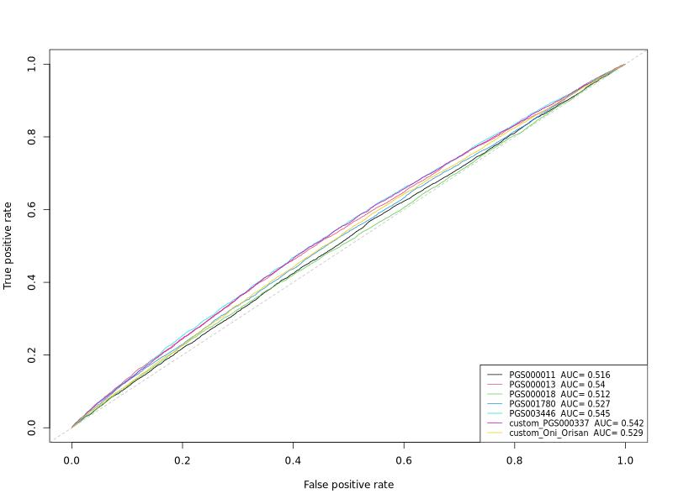 Partial

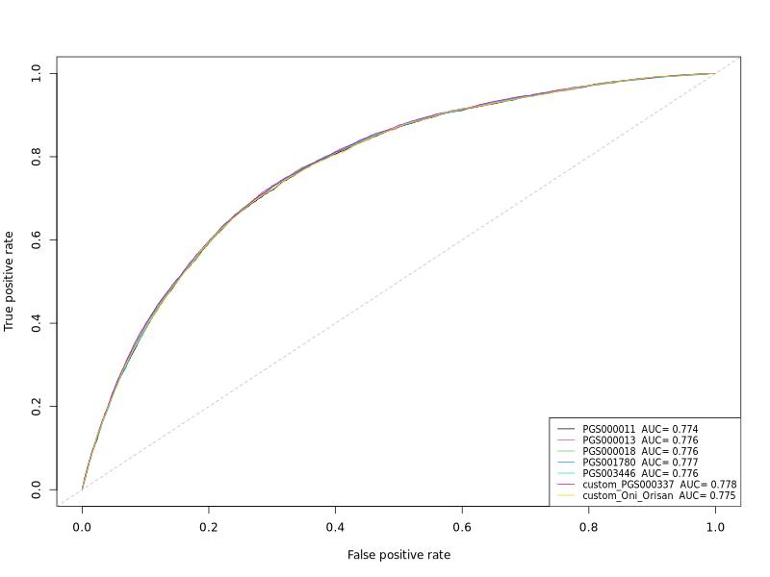 Full

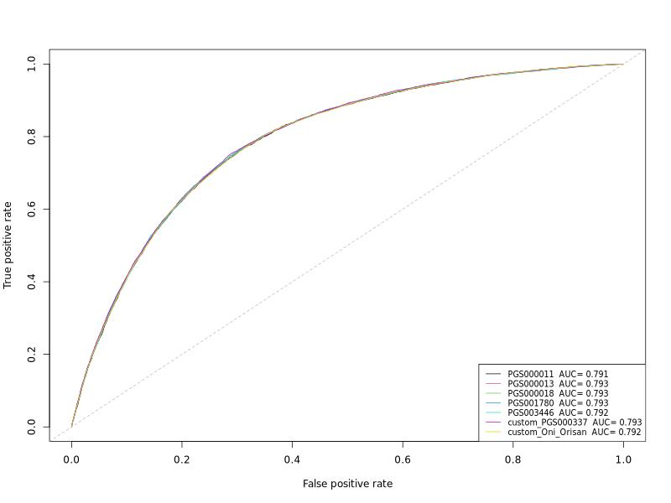

Full mode

## Categorical PRS

| **95% CI** | **PGS000011+** | **PGS000013+** | **PGS000018+** | **PGS001780+** | **PGS003446+** | **custom_PGS000337+** | **custom_Oni_Orisan+** |
| --- | --- | --- | --- | --- | --- | --- | --- |
| **Number of SNPs** | 44 | 6,472,620 | 1,720,068 | 1,087,958 | 485,464 | 64,185 | 141 |
| **Simple Model\*** |  |  |  |  |  |  |  |
| OR (intermediate vs Low) | 1.041(0.971-1.116) | 1.166(1.084-1.254) | 0.987(0.921-1.058) | 1.059(0.987-1.137) | 1.179(1.096-1.269) | 1.158(1.077-1.245) | 1.135(1.057-1.219) |
| OR (high vs Low) | 1.153(1.061-1.253) | 1.45(1.334-1.577) | 1.159(1.068-1.258) | 1.244(1.146-1.352) | 1.54(1.417-1.675) | 1.46(1.343-1.588) | 1.302(1.198-1.417) |
| AUC | 0.512(0.505-0.518) | 0.53(0.523-0.537) | 0.514(0.507-0.521) | 0.518(0.511-0.525) | 0.535(0.529-0.542) | 0.531(0.524-0.538) | 0.521(0.514-0.528) |
| Nagelkerke_PseudoR2 | 0.0003232276 | 0.0020212813 | 0.0005875227 | 0.0007930176 | 0.0028217821 | 0.0021428589 | 0.0009774451 |
| lee_PseudoR2 | 0.0006832971 | 0.0042462403 | 0.0012085469 | 0.0016416195 | 0.0058061785 | 0.0044538172 | 0.0021191863 |
| **Adjusted Model$** |  |  |  |  |  |  |  |
| OR (intermediate vs Low) | 1.047(0.974-1.124) | 1.204(1.118-1.298) | 1.253(1.161-1.353) | 1.224(1.136-1.319) | 1.15(1.062-1.245) | 1.241(1.151-1.337) | 1.145(1.064-1.232) |
| OR (high vs Low) | 1.175(1.079-1.28) | 1.519(1.393-1.656) | 1.698(1.54-1.873) | 1.589(1.451-1.739) | 1.439(1.302-1.59) | 1.646(1.509-1.795) | 1.307(1.199-1.426) |
| AUC | 0.774(0.768-0.78) | 0.776(0.77-0.781) | 0.776(0.77-0.782) | 0.776(0.77-0.782) | 0.775(0.769-0.781) | 0.776(0.771-0.782) | 0.774(0.768-0.78) |
| Nagelkerke_PseudoR2 | 0.1375215 | 0.1394115 | 0.1399505 | 0.1396387 | 0.1385090 | 0.1403407 | 0.1380409 |
| lee_PseudoR2 | 0.2283931 | 0.2312938 | 0.2319888 | 0.2316070 | 0.2296542 | 0.2325795 | 0.2291802 |
| **Fully Adjusted Model§** |  |  |  |  |  |  |  |
| OR (intermediate vs Low) | 1.063(0.988-1.144) | 1.168(1.083-1.26) | 1.211(1.12-1.309) | 1.197(1.109-1.291) | 1.13(1.042-1.226) | 1.2(1.112-1.295) | 1.135(1.053-1.223) |
| OR (high vs Low) | 1.172(1.074-1.279) | 1.478(1.354-1.613) | 1.612(1.46-1.781) | 1.52(1.386-1.667) | 1.361(1.229-1.507) | 1.54(1.41-1.683) | 1.277(1.169-1.395) |
| AUC | 0.791(0.786-0.797) | 0.792(0.786-0.798) | 0.793(0.787-0.798) | 0.792(0.787-0.798) | 0.792(0.786-0.797) | 0.793(0.787-0.798) | 0.791(0.786-0.797) |
| Nagelkerke_PseudoR2 | 0.1541248 | 0.1558051 | 0.1560748 | 0.1558001 | 0.1547440 | 0.1561628 | 0.1545295 |
| lee_PseudoR2 | 0.2511415 | 0.2538790 | 0.2540522 | 0.2537747 | 0.2518644 | 0.2541080 | 0.2516668 |
| +PRSs are divided in to 5 quintiles, Low PRS=Q1, Intermediate PRS=Q2-4, High PRS=Q5 | | | | | | | |
| *No adjustments | | | | | | | |
| $Adjust for Age at baseline, Sex and 7 genetic PCs | | | | | | | |
| §Partial model adjustments + waist-to-hip ratio, systolic and diastolic blood pressure, education attainmen level, smoking status,diabetes at baseline | | | | | | | |

### AUC plots

Simple

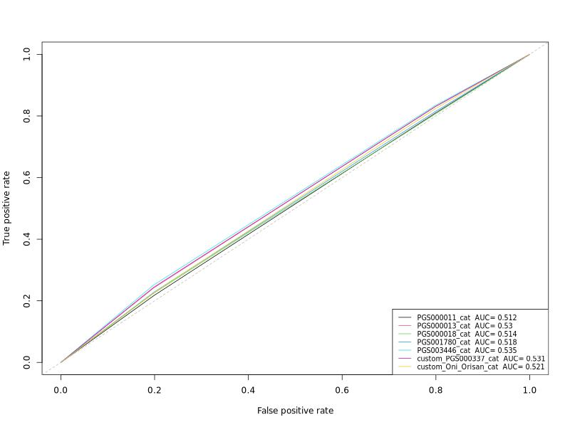 Partial

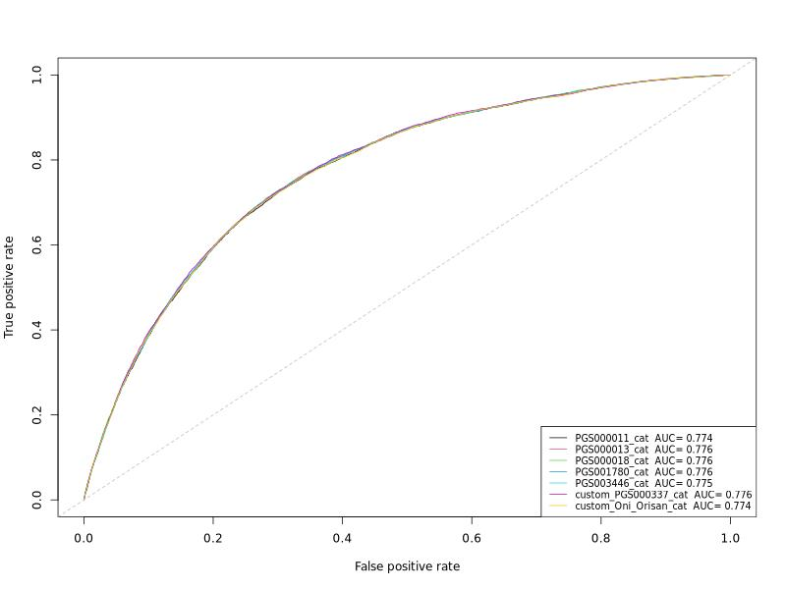 Full

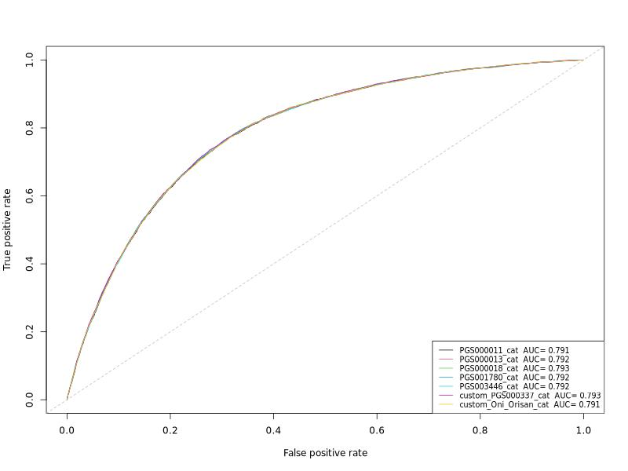

full model with categorical PRS